1. It requires no knowledge about querying language sql, excel. It is very easy for stakeholders to query. Eg : Show total students and total teachers from school.
2. Web front end manages two components initial connection and user authentication. Front end act like intermediate between user and back end
3. Back end take care of data visualization, datasets, storage, report, connections.
4. ASP.NET plays main role to publish reports. Stakeholders can view the reports in power bi service.
5. 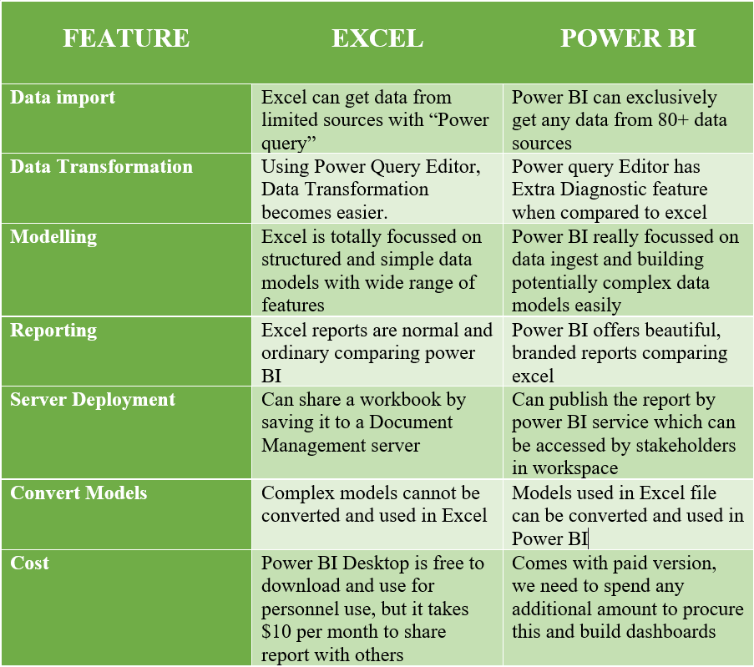

1. Excel, text/csv, folder, pdf, xml, JSON, sql server database, parquet, access database, sharepoint folder, Mysql database, oracle server, IBM Netezza, IBM Informix database, sql server analysis database, IBM db2 database. Snowflake, impala, google cloud, github,twilio.